Programming Fundamentals- Fall 2025

HOSPITAL MANAGEMENT SYSTEM




User Interface Report

Version 1.0

Submitted By: 2025-AI-36 (Section A)
Instructor: Ms. Khushbakht

Department of Computer Science
University of Engineering and Technology Lahore

Contents
Project Details 3
Project Summary 3
Project Features 3
Interfaces Details 4
Main Menu 4
Add Hospital Data: 4
Show The Hospital Data: 6
Add Patient Data: 6
Show the Patient Data 8
Sort Hospital by Bed Price 9

Project Details

Project Summary
- This project is a Hospital Management System made using the C programming language. The main purpose of this program is to store and manage hospital and patient records in an easy way.
- The program allows the user to add hospital details such as hospital ID, name, city, available beds, bed price, rating, and number of reviews. All hospital data is saved in a file so it can be used later.
- It also allows the user to add patient details like patient ID, name, age, disease, and the hospital where the patient is admitted. Patient data is also stored in a separate file.
- The user can view all hospitals and view all patients. When showing patient details, the program also displays the name of the hospital where the patient is admitted.
- Another feature of this project is sorting hospitals by bed price from high to low, which helps users compare hospital costs easily.
- Overall, this project helps in managing hospital and patient information, uses file handling, structures, and menu-based programming, and is suitable for beginners learning C programming.

Project Features

- Menu-based program that is easy to use.
  - Add new hospital records.
- Store hospital details (ID, name, city, beds, price, rating, reviews).
- Save hospital data using file handling.
- Add new patient records.
- Store patient details (ID, name, age, disease, hospital ID).
- Save patient data in a separate file.
- Display all hospital records.
- Display all patient records.
- Show hospital name for each patient.
- Sort hospitals by bed price from high to low.
- Uses structures for organized data storage.
- Uses files so data is not lost after closing the program.
.

Interface Details

Main Menu:
Purpose of The Menu
The purpose of the menu is to give the user an easy way to choose different options in the program.
It helps the user add, view, and manage hospital and patient records step by step.
The menu makes the program simple to use without remembering commands.
It also allows the program to run continuously until the user chooses to exit
Input/Output

Input is the data given by the user to the program.
It includes hospital information such as ID, name, city, beds, price, and rating.
It also includes patient details like ID, name, age, disease, and hospital ID.Output is the data shown by the program on the screen.
It displays hospital records, patient records, hospital names for patients, and sorted hospital lists.
Validation
Validation is used to make sure the entered data is correct and meaningful.
It helps prevent wrong or empty input from the user.
Validation ensures values like age, beds, and price are in the correct range.
It also checks that the hospital ID entered for a patient exists.
This makes the program more reliable and error-free.

Screenshot
Figure 1.1: Main Menu
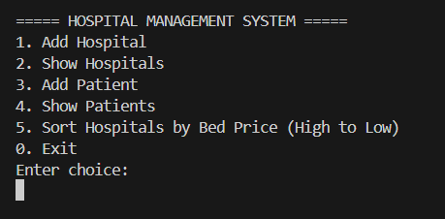

Figure 1.2: Exit Option
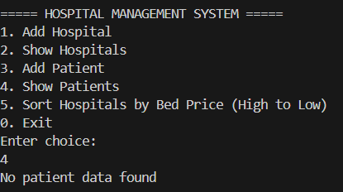

Add Hospital Data:
Purpose of The Menu:
The purpose of the menu for adding hospital data is to allow the user to easily enter new hospital details like ID, name, city, beds, price, rating, and reviews.
It guides the user step by step to input correct information.
This option also saves the data in a file so it can be used later.
It makes adding hospitals organized and easy to manage.

Input/Output:
Input:
- Hospital ID (number)
- Hospital Name (text)
- City (text)
- Available Beds (number)
- Bed Price (decimal/float)
- Hospital Rating (decimal/float, 0–5)
- Number of Reviews (number)
Output:
- Confirmation message: “Hospital added successfully!”
- The data is saved to the file (hospital.dat) for future
Validation
Validation for the Add Hospital Data option ensures that the entered hospital information is correct and meaningful:
- Hospital ID should be a positive number and unique (no duplicates).
- Hospital Name and City should not be empty.
- Available Beds must be a positive number.
- Bed Price should be a positive decimal value.
- Hospital Rating must be between 0 and 5.
- Number of Reviews should be 0 or more.
This ensures the program does not store invalid data and works accurately.
.
Screenshot

Figure 2.1: Add Hospital Data
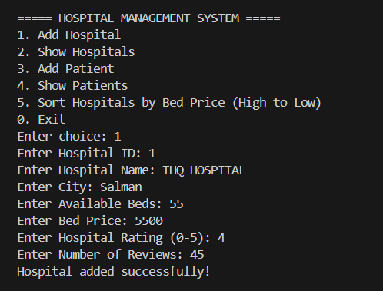

Show The Hospital Data:
Purpose of The Menu
The Show Hospital function is used to display all hospital records stored in the file.
It allows the user to view hospital details like ID, name, city, beds, price, rating, and reviews.
This helps the user check and manage hospital information easily.
Input/Output
Input:
- No input is required from the user to display hospitals, except choosing the “Show Hospitals” option from the menu.

Output:
- A list of all hospitals showing:
  - Hospital ID
  - Hospital Name
  - City
  - Available Beds
  - Bed Price
  - Rating
  - Number of Reviews
- If no hospitals are added, it shows “No hospital data found.”

Validation
- Checks if the hospital file exists before reading.
- Displays a message if no hospital records are found.
Ensures only valid hospital data from the file is shown
Sscreenshot

Figure 2.3: Show Hospital Data

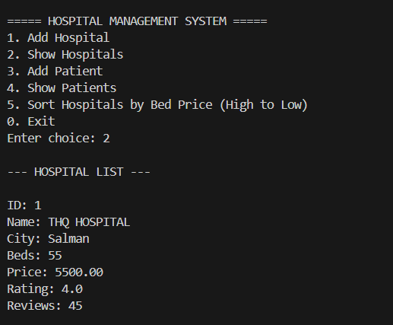

F

Add Patient Data:
Purpose of The Menu
The Add Patient function allows the user to enter and save new patient details.
It stores information such as patient ID, name, age, disease, and hospital ID.
This helps the hospital keep track of patients and their assigned hospitals.
Input/Output
Input:
- Patient ID (number)
- Patient Name (text)
- Age (number)
- Disease/Condition (text)
- Hospital ID (number, where the patient is admitted)
Output:
- Confirmation message: “Patient added successfully!”
- The patient data is saved in a file (patient.dat) for later use.

Validation

• Patient ID should be a positive number and preferably unique
• Patient Name and Disease/Condition should not be empty.
• Age should be a positive number within a reasonable range (e.g., 0–120).
• Hospital ID must exist in the hospital records before assigning a patient.
Screenshot

Figure 3.1: Add patient data
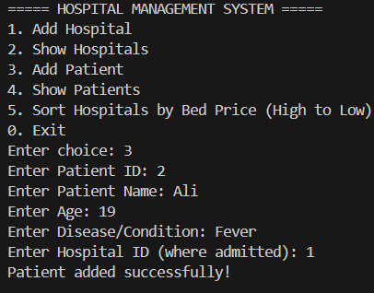

Show the Patient Data:
Purpose of The Menu
The Show Patient function allows the user to view all patient records stored in the file.
It shows patient details like ID, name, age, disease, and the hospital where they are admitted.
This helps monitor patients and check which hospital they are assigned to
Input/Output
Input:
- No direct input from the user is required, except selecting the “Show Patients” option from the menu.

Output:
- A list of all patients displaying:
  - Patient ID
  - Name
  - Age
  - Disease/Condition
  - Hospital ID
  - Hospital Name (matched using hospital ID)
- If no patient records are found, it shows “No patient data found.”

Validation
• Checks if the patient file exists before reading.
• Ensures only valid patient data is displayed.
• Verifies the hospital ID exists in hospital records to correctly show the hospital name.
• Displays a message if no records are found.
.
Screenshot

Figure 3.3: Show The Patient List
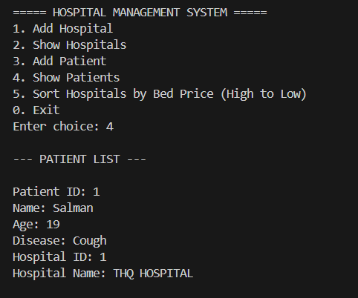

Sort Hospital by Bed Price:
Purpose of The Menu
The Sort Hospitals by Bed Price function allows the user to view hospitals arranged from highest to lowest bed price.
It helps users compare hospital costs easily and make informed choices.
Input/Output
Input:
- No direct input from the user is required, except selecting the “Sort Hospitals by Bed Price” option from the menu.
Output:
- A list of hospitals displayed in order of bed price (high to low):
  - Hospital ID
  - Name
  - City
  - Available Beds
  - Bed Price
  - Rating
  - Number of Reviews
- If no hospitals are stored, it shows “No hospital data found.”

Screenshot

Figure 3.4: Hospital By Bed price
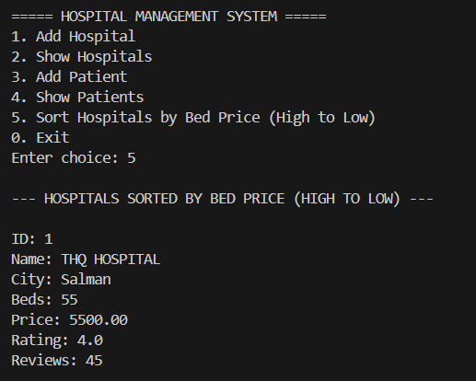
F

